Arduino Lesson 11
Photosensitive Lights
- Intro
Now you may have some basic knowledge about Arduino after the
previous experiment.Before we show you the basic digital value
input,the analog value output and PWM, we can start some applications
for sensors.

Photovaristor is a type of resistors,its resistence varies from the external
light strength by the photoelectric effects of semiconductor. The
resistence becomes smaller when the light is harder, vise versa.

Photovaristor generally used on light measurement,light-control and
photovoltaic conversion,light-control switch as well.

This experiment is a simple one.We can take example by PWM experiment,just change the potentiometer to photovaristor.When light strength changes, LED brightness will change relevantly.
- Parts required
Photovaristor x 1
Red 5mm LED x 1
10KΩ Resistor x 1
220Ω Resistor x 1
Breadboard x 1
Jumper wires x 1 Bundle
- Connect-it-up
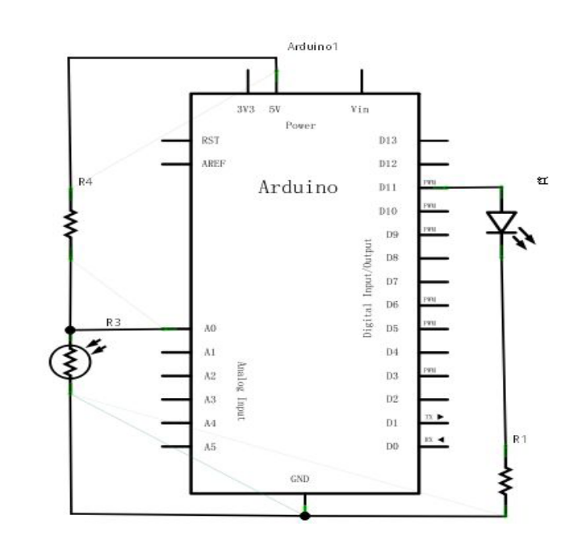
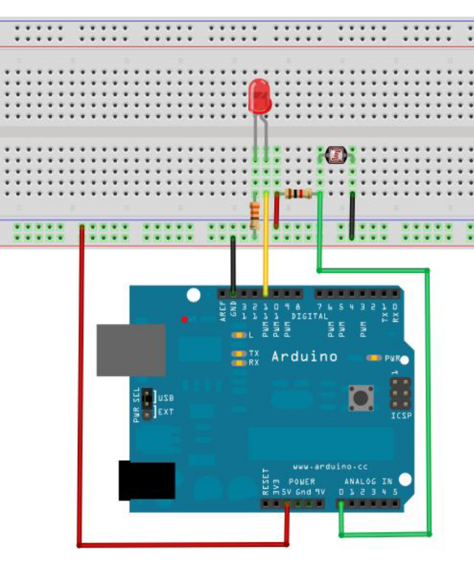

- Programing
The program is similar with PWM experiment, some changes apply
on values assignment part.Below codes for reference.
int potpin=0;//set analog interface #0 to connect photovaristor
int ledpin=11;//set digital interface #11 output PWM to adjust the led brightness
int val=0;//define variable val
void setup()
{
pinMode(ledpin,OUTPUT);//set digital interface #11 as output
Serial.begin(9600);//set baud rate as 9600
}
void loop()
{
val=analogRead(potpin);//read analog value from sensor and
assign to val
Serial.println(val);//显示val 变量数值display val value
analogWrite(ledpin,val);// turn on led and set up brightness（PWM max output value 255）
delay(10);//delay 0.01 s
}

Here we divide the returned value by 4.Because analog input function returned value range from 0 to 1023,but analog output function returned value range from 0-255.
Download the program and try to change the light strength and
You can see led is changing the brightness.

